# Competition

Currently, there are a very few players who are tapping the potential of truly automated stores with self checkout features. Some of them include the Amazon-Go stores located in the USA, Ai-Fi - which provides retail solutions to make existing stures automatic. Other similar ventures include Grabango, MishiPay, Shopic, Caper etc who are new age startups exploring this space, but most of these lack scalability and cost effectiveness. Our solution is unique in this regard. For instance, The Amazon - Go and Ai-FI stores use an insane amount of sensors and sophisticated systems to track the customers in the store which leads to the cost of the store blowing up but at a disproportionate gain. Whereas our solution is clean and simple which can be readily implemented at any store for a much lower cost compared to our competition while preserving the customer experience. This can be an added benefit while acquiring new customers.

The below chart shows the competitive advantages of CheckItOut when compared to traditional shopping options as well as some of the high spec peers such as the Amazon-Go stores.

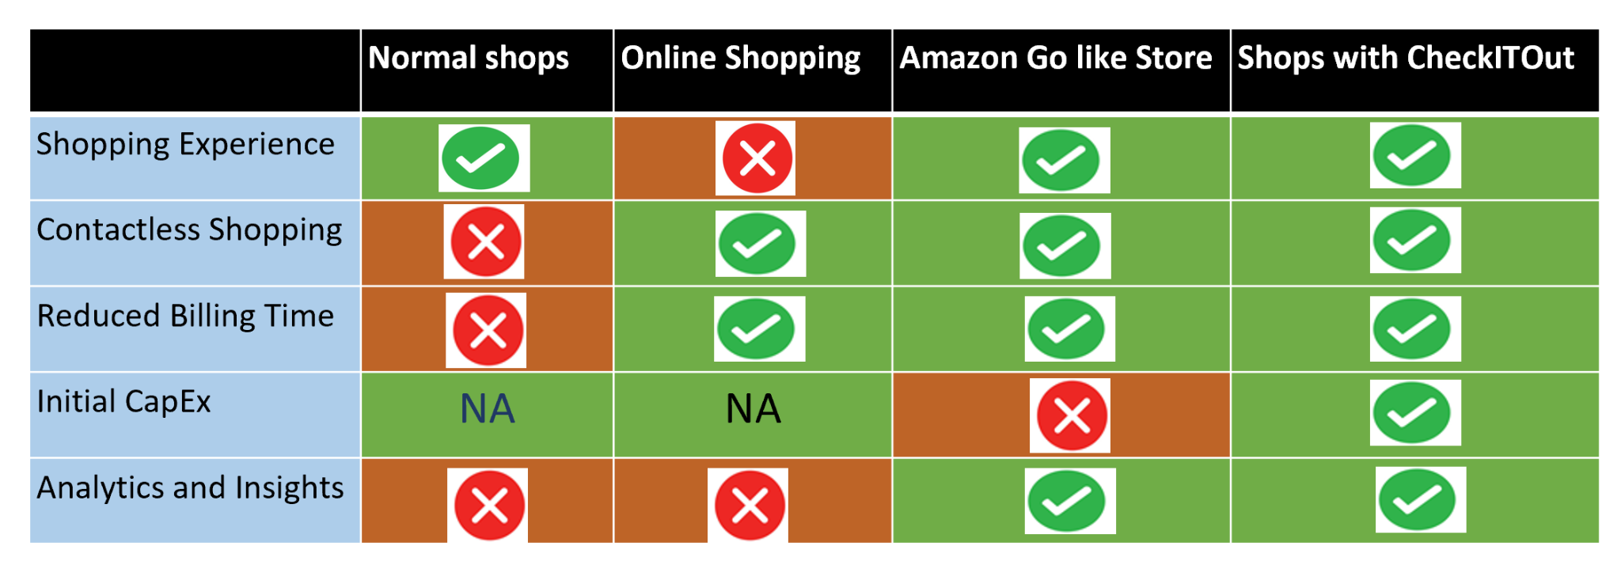

# Experience

The consumer experience at CheckItOut would be seamless, as the entire checkout process would be facilitated in the bay cabin automatically and the customer only has to approve the payment before leaving the store, moreover the incentives to a store owner for switching to CheckItOut based system would outweigh the minimal cost as his regular cash-flows towards maintaining manual staff at the store would be completely eliminated. An added benefit to the store would be the robust data analytics that we provide which can potentially boost his sales and help serve his customers better than ever.

# 